LETSUPGRADE DATA STRUCTURES AND ALGORITHM

DAY 2 ASSIGNMENT

Q1)Write the program for deleting an element from the beginning and from any position.

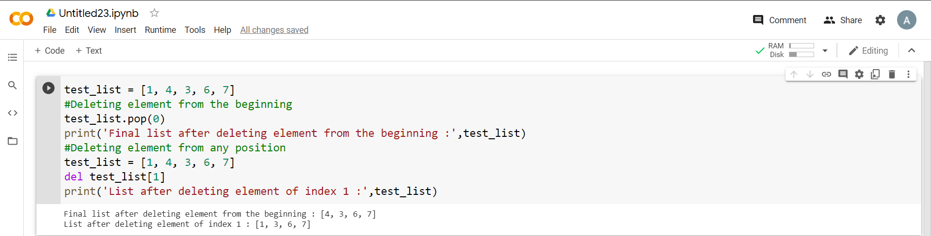

Q2) Write the program for printing the array after rotating it k times towards left, where k would be taken as user input.

